# PROG 2500 Windows PRogramming - Assignment 3

# UWP Applications – Local Note, Part II

Assignment Value: 12.5% of overall course mark.

Due Dates: **See due date on A3 dropbox – Marked by code review during scheduled class time**

Late submissions will receive the standard late submission penalty as stated in the course outline. (5% overall deduction per day late, and 0% after assignment handed back to the class.)

#### Assignment Instructions:

In Visual Studio, use XAML/C# to create a UWP application as described by the requirements of this assignment.

#### Submissions:

Submission of work will be achieved through your GitHub repository. Please ensure that the commit you wish to have marked is labelled with an appropriate Commit Comment in your repo and that you upload a text file with your commit ID to Brightspace. Unless otherwise specified, your most recent commit prior to the assignment deadline will be the one chosen for evaluation.

#### Evaluation:

To insure the greatest chance of success on this assignment, be sure to check the marking rubrics at the end of this document or in Brightspace. The rubrics contain the criteria your instructor will be assessing when marking your assignment.

## Program – LocalNote, Part II

## Continue the development of the LocalNote app created in Assignment Two, with the additions listed below.

**Note:** All primary application functionality from the previous assignment is expected to work properly, which means errors/omissions from the previous submission are required to have been fixed. This doesn’t mean every cosmetic issue or small-scale bug must be fixed, but you will lose marks on this version of the app if primary elements of the app are missing or broken.

**Additional Functionality:**

* Functionality from previous app should continue to work as expected.
* A separate project for Unit Testing will be added, and will contain test coverage for all non-UI application functionality.
* Add an appropriate Splash Screen image & and application icons.
* Add **Delete** functionality to allow the deletion of an existing note. It should be available from a Delete button in the command bar, and must present an asynchronous dialog that confirms whether to delete a note.
* Add two secondary items on the command bar: **About** and **Exit**. The **About** button presents developer and app details in an asynchronous dialog. The **Exit** Button exits the app.
* **Validation**:
  + If a note is deleted, the text should be removed from main edit section and no note selected.
* The UI should now be fairly polished and present a friendly and appealing user experience.

Sample Screenshots

Deleting a Note

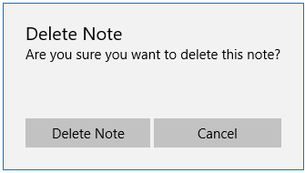

Commands & Menu

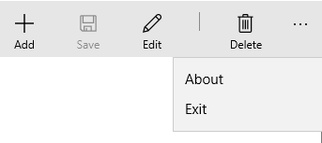

About Screen

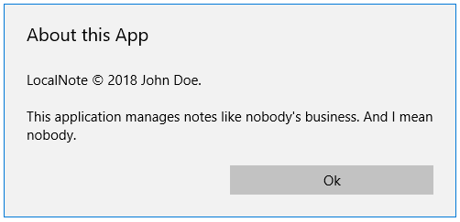

|  |  |  |  |  |  |
| --- | --- | --- | --- | --- | --- |
| **Application – LocalNote, Part II** | |  |  |  |  |
| **Criteria** | **Insufficient (0 pts)** | **Sufficient (1 pt)** | **Excellent (2 pts)** | **Mark** | **X** |
| **Prior Functionality** | Multiple requirements or elements not working as expected, or missing. | At least one requirement or element does not work as expected, or is missing. | All primary functionality from previous assignment requirements present and working as expected |  | 2 |
| **Note Deleting** | Functionality has multiple errors or omissions. | Functionality has one error or omission. | Functionality to delete notes added and working as expected, with no errors. |  | 2 |
| **Delete Confirmation** | Functionality has multiple errors or omissions. | Functionality has one error or omission. | Deleting a note confirmed using an asynchronous dialog, and works as expected with no errors or omissions. |  |  |
| **Unit Testing** | Unit Tests not present, has insufficient coverage or contain multiple errors. | Unit Tests present but do not cover most of the program, or contain some errors. | Unit Tests present and cover all non-UI program functionality. |  | 3 |
| **About Screen** | Functionality has multiple errors or omissions. | Functionality has one error or omission. | An About screen displays as an asynchronous dialog when the secondary menu item is clicked, and works as expected. |  |  |
| **Splash Screen/Icons** | Functionality has multiple errors or omissions. | Functionality has one error or omission. | Splash Screen and application icons present and working. |  |  |
| **Exit Command** | Functionality has multiple errors or omissions. | Functionality has one error or omission. | The Exit menu choice properly exits the application. |  |  |
| **Validation** | Functionality has multiple errors or omissions. | Functionality has one error or omission. | If a note is deleted, the text should be removed from main edit section and no note selected. |  |  |
| **App Polish** | Little to no effort made to create a polished and useable UI. | Some improvements could be made. | App’s UI is well-designed and visually appealing. Functionality and layout is user-friendly and polished. |  |  |
|  |  |  | **Total:** |  | **/26** |